**DAILY ONLINE ACTIVITIES SUMMARY**

|  |  |  |  |  |  |  |  |  |
| --- | --- | --- | --- | --- | --- | --- | --- | --- |
| **Date:** | **04/06/2020** | | | | | **Name:** | **VIRESH** | |
| **Sem & Sec** | **4th SEM & ‘B’ SEC.** | | | | | **USN:** | **4AL18CS097** | |
| **Online Test Summary** | | | | | | | | |
| **Subject** | | **Microcontroller And Embedded Systems** | | | | | | |
| **Max. Marks** | | **20** | | **Score** | | | **16** | |
| **Certification Course Summary** | | | | | | | | |
| **Course** | **Cloud Foundations** | | | | | | | |
| **Certificate Provider** | | | **Greatlearning Academy** | | **Duration** | | | **4.5 Hrs.** |
| **Coding Challenges** | | | | | | | | |
| **Problem Statement 1:** Write a C++ program to find the missing number in array.  **Problem Statement 2:** write a java program to read three integer values from the keyboard and find the sum of the values. Declare a variable &quot;sum&quot; of type int and store the result in it. | | | | | | | | |
| **Status: Done** | | | | | | | | |
| **Uploaded the report in Github** | | | | | **Yes** | | | |
| **If yes Repository name** | | | | | **Lockdown-Coding**  <https://github.com/viresh-kulal/Lockdown-Coding>  <https://github.com/alvas-education-foundation/Viresh/tree/master/coding_solutions> | | | |
| **Uploaded the report in slack** | | | | | **Yes** | | | |

**Online Test Summary: 18CS44 test was scheduled from 2:00pm to 2:30pm .The portion for the IA was 3rd module there were 20 questions and the time assigned was 30 minutes the questions were MCQ type.**

**The snapshot of the completion of the test and the marks allotted is attached below.**

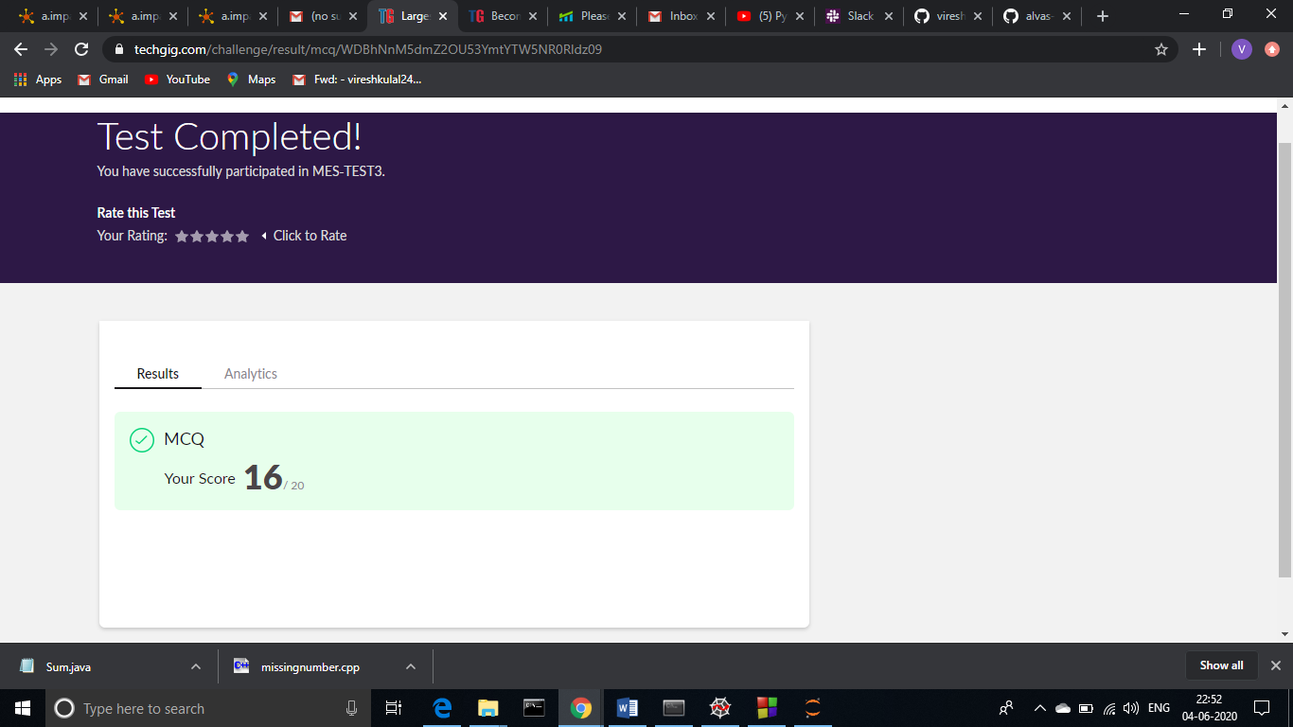

**Online Certification Course Summary: Today** **I learnt what is Infra.Automation, Abstraction, Provisioning and Allied Tech. Along with this I have successfully completed the course by attending the quiz.**

**The snapshots of today’s session is attached below.**

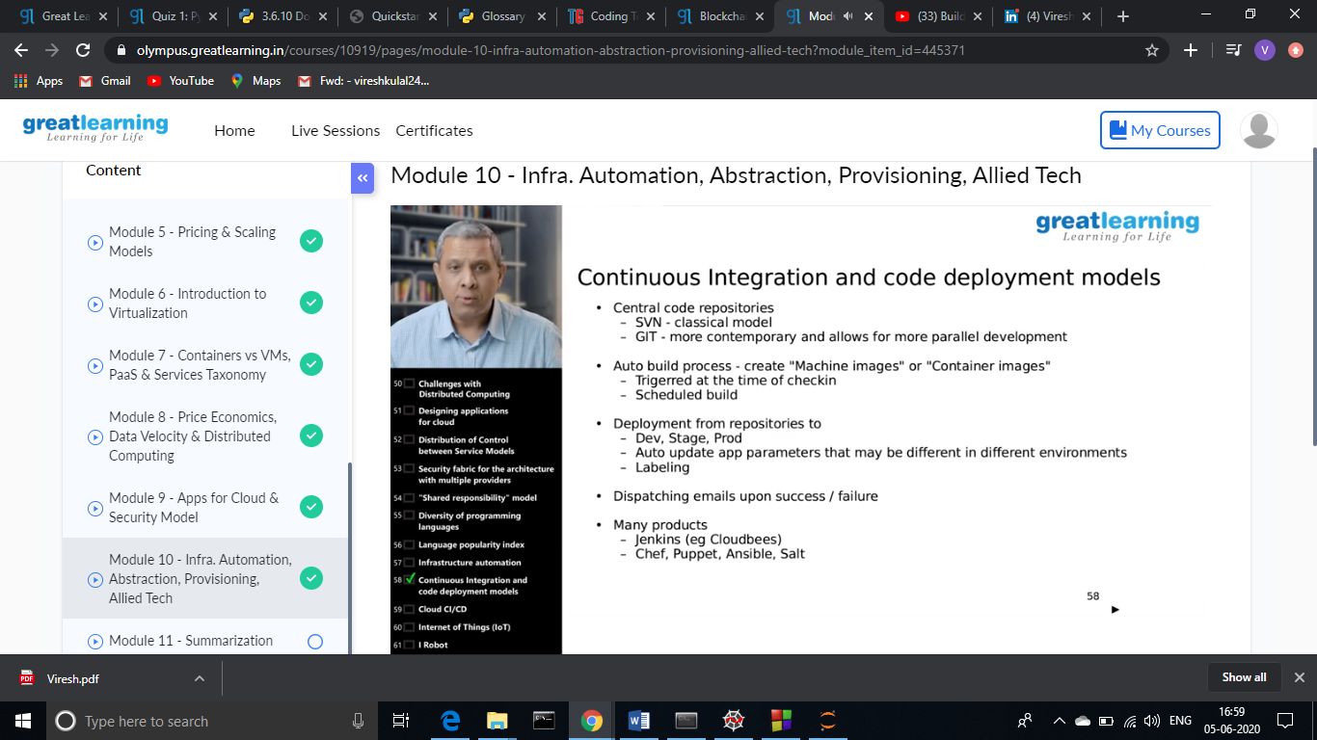

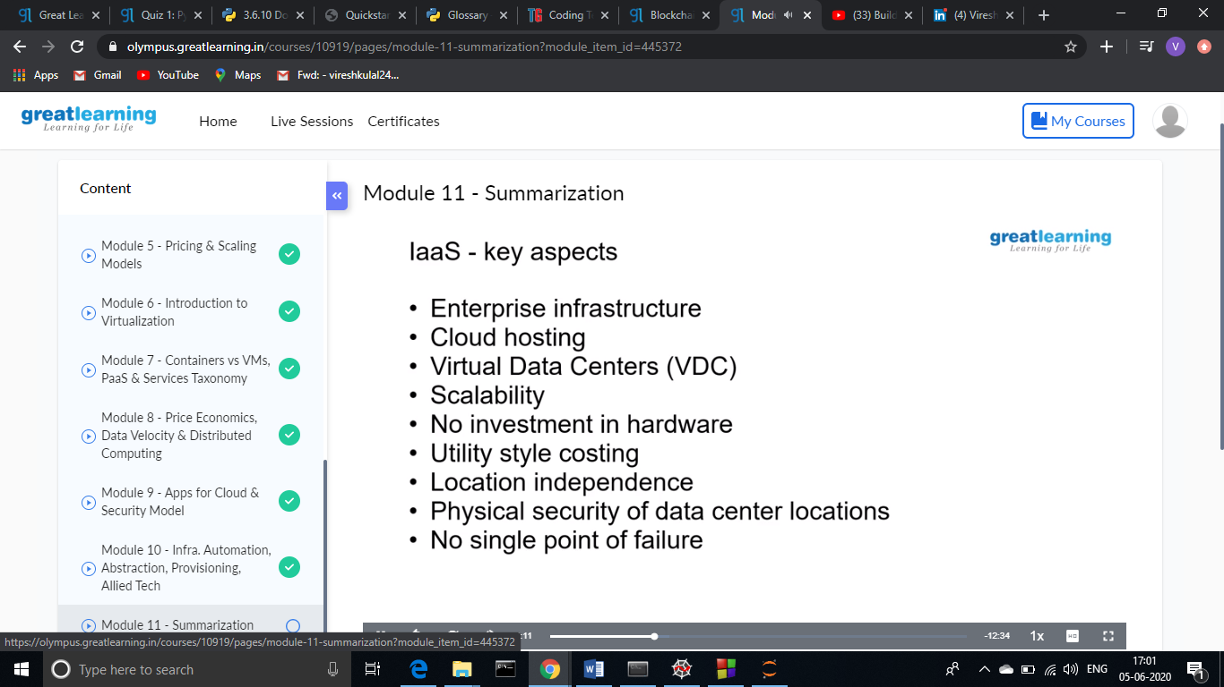

**This is the snap shot of the quiz attempted and the grades obtained.**

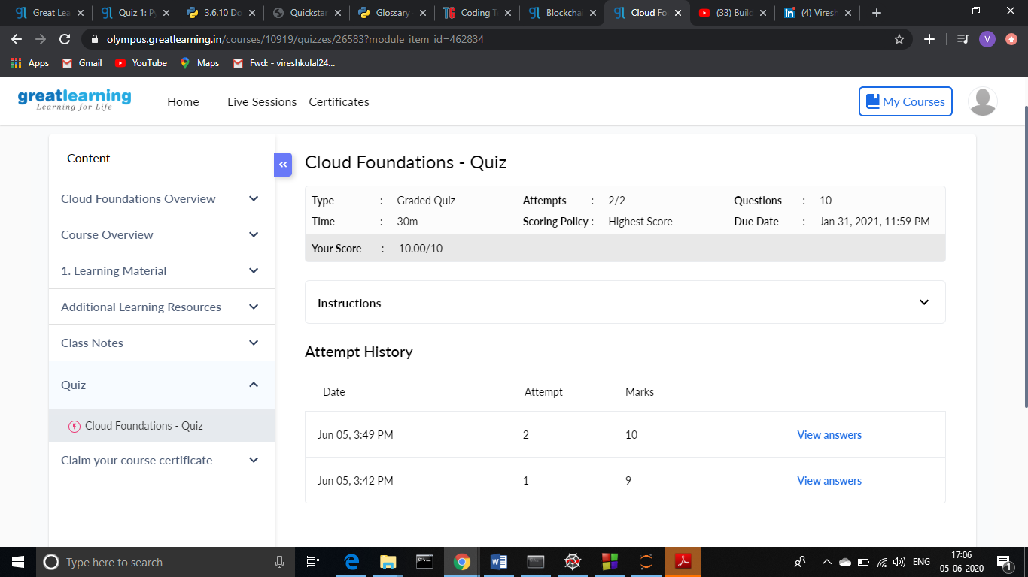

**This is the certificate of completion of the course.**



**Online Coding Summary: Today I had received one program from prof. Shilpa CSE Dept. the other from Prof. Reena Lobo CSE Dept. The program is mentioned above (pg.01). I have also uploaded it to my Github repository.**

The Repository link is: <https://github.com/viresh-kulal/Lockdown-Coding>

<https://github.com/alvas-education-foundation/Viresh/tree/master/coding_solutions>

The snapshots of my Github repository were I have uploaded the code. File names are Sum.java and missingnumber.cpp which are shown below.

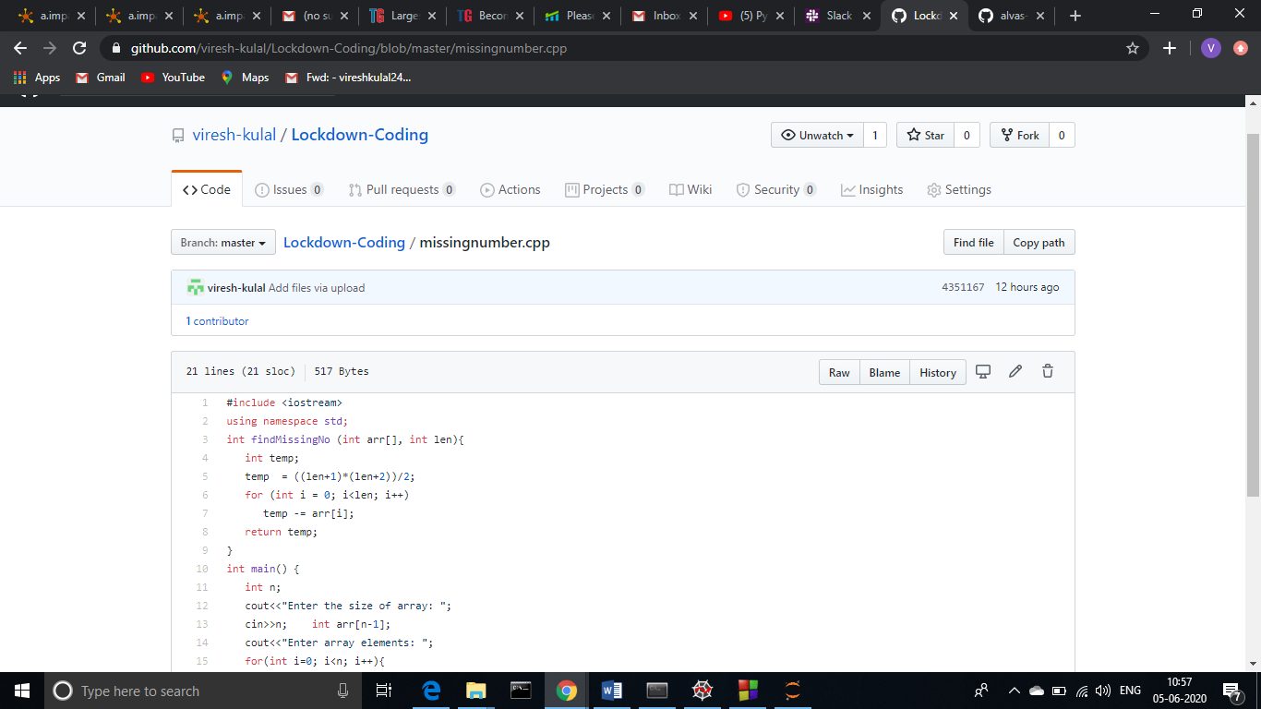

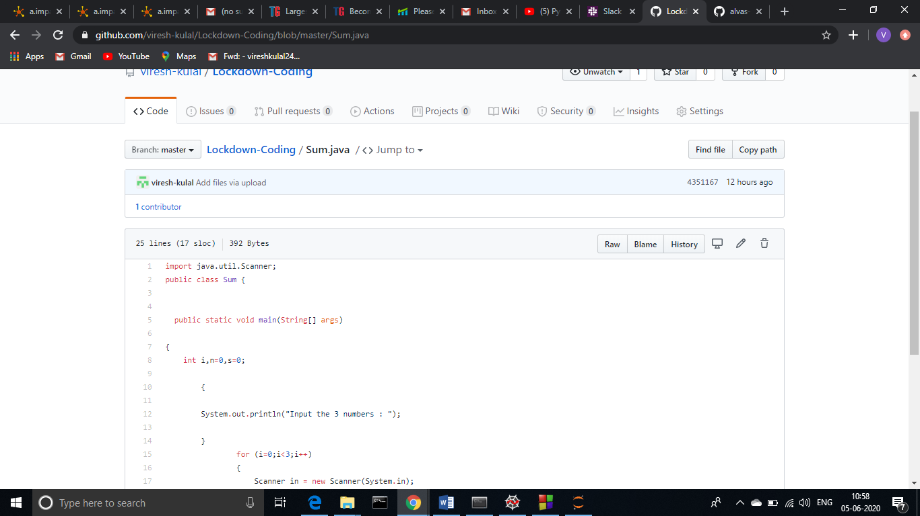

**Thank you.**